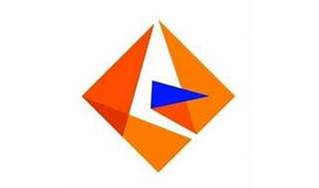



Explore

Certainly! **Informatica** is a software development company that offers data integration products, including ETL (Extract, Transform, Load), data masking, data quality, data replication, and master data management. [Their flagship tool, **Informatica PowerCenter**, is widely used for ETL and data integration tasks1](https://www.guru99.com/introduction-informatica.html)[2](https://en.wikipedia.org/wiki/Informatica).

Here are **five free reference links** where you can learn more about Informatica:

1. [**Guru99 Informatica Tutorial**](https://www.guru99.com/introduction-informatica.html): This comprehensive tutorial covers Informatica’s meaning, architecture, installation, transformations, and more[3](https://www.guru99.com/informatica-tutorials.html).
2. [**edX Informatica Courses**](https://www.edx.org/learn/informatica): Explore online courses to enhance your programming skills related to Informatica[4](https://www.edx.org/learn/informatica).
3. [**Udemy: Getting Started with Informatica**](https://www.udemy.com/course/getting-started-with-informatica/): Learn the basics of Informatica, including using the admin console, transformations, and setting up connections[5](https://www.udemy.com/course/getting-started-with-informatica/).
4. [**Informatica University**](https://www.informatica.com/services-and-training/informatica-university.html): Access role-based training programs and resources to maximize your understanding of Informatica products[6](https://www.informatica.com/services-and-training/informatica-university.html).
5. [**Informatica’s Microlearning Platform**](https://network.informatica.com/s/get-started): A feature-rich platform offering free and unlimited learning on Informatica products[7](https://network.informatica.com/s/get-started).

Feel free to explore these resources to dive deeper into Informatica! 🚀